OPEN SEASON – FLY-OUT MIDDEN ZEELAND

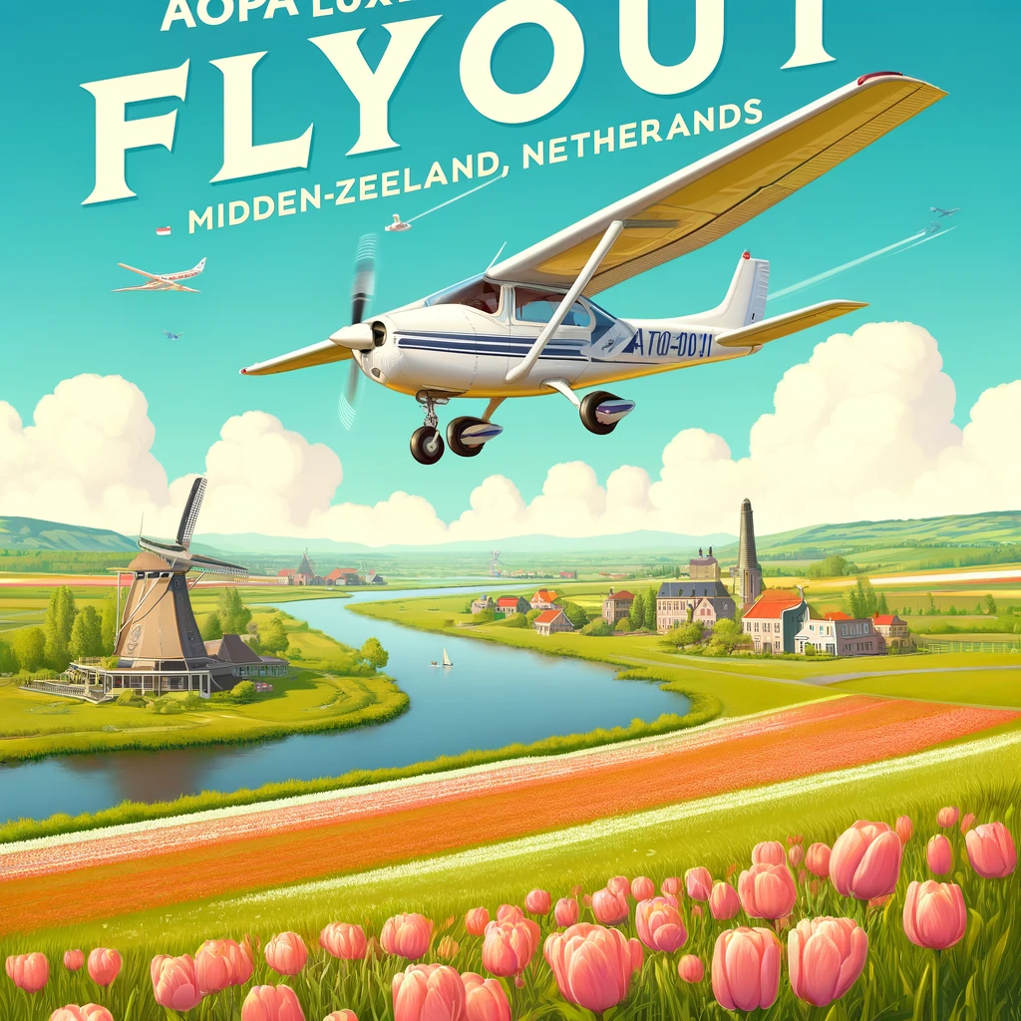

Invitation to the AOPA Luxembourg Fly-Out to Midden Zeeland

Dear members and friends of AOPA Luxembourg,

We are delighted to invite you to an exclusive event: a fly-out on Wednesday May 1st, from Luxembourg and its surroundings, to Midden Zeeland Airport (EHMZ) in the Netherlands – a destination where May 1st is not a public holiday.

Midden Zeeland, an innovative airport:
Our destination, Midden Zeeland, is known for its unique airstrip. Reinforced by synthetic fibers from old artificial turf fields, this method offers a smooth and stable surface, perfectly usable even in uncertain weather. A technical feat to discover!

For adventurers:
For adventure-seeking pilots, the airport offers an exciting option: e-bike rental for an excursion to the charming village of Veere, located just 30 minutes away. An ideal way to discover the picturesque landscapes and serene atmosphere of this Dutch pearl.

For gourmets:
If you prefer to enjoy a moment of relaxation, the restaurant at Midden Zeeland Airport awaits you. With its magnificent terrace, it is the perfect place to enjoy a delicious meal while admiring the aerial panorama. Lunch scheduled for 12.30 at the airfield

Event Details:

Date : Wednesday May 1
Departure location : Luxembourg and surrounding areas
Destination : Midden Zeeland Airport (EHMZ), Netherlands – 150 NM
Activities : Group flight, cycling in Veere, meals on the terrace
Registration and information : This event is an excellent opportunity to combine your passion for flying with the discovery of new cultures and landscapes.

Join us for an unforgettable day full of adventures and encounters! For any questions, do not hesitate to contact Peter Sodermans : peter.sodermans@aopa.lu (+352) 691.90.91.92

Looking forward to flying together,

The AOPA Luxembourg

REGISTRATION FORM to be returned before April 25

e-mail: info@aopa.lu

I, the undersigned):

Address:

Postal code: CITY:

EMAIL for briefing: GSM:

Would like to participate: club plane with call sign _____________
in a private plane with call sign ______________

Passengers: Last name: First name:

Last name First Name:

Last name First Name:

I would like to compensate the CO2 emissions of my flight by a voluntary donation of 20€

Wednesday May 1 , 2024 Arrival in Midden Zeeland around: hours
Would like to book an electric bike for ___ people to visit the picturesque village of Veere
Would like to join the Luxembourg pilots table at 12.30 with ____ people

************************************************** *

Briefing: Thursday April 25 at 6 p.m. by videoconference. Please send us your email address to be able to receive the invitation for the digital briefing

